SP
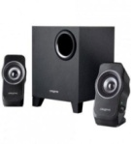 | Creative SBS A335 2.1 | - 2.1 Channel Configuration  - 1 Subwoofer  - 2 Satellites  - 75 dB Signal-to-Noise Ratio  3.5 mm Stereo Jack | Rs. 2299 | 16 | Rs. 1931
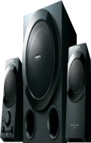 | Sony SRS-D9 2.1 | - 2.1 Channel Configuration  - 1 Subwoofer  - Total Output of 60 W RMS  - 2 Satellites  - 1 x USB Port | Rs. 5299 | 0 | Rs. 5299
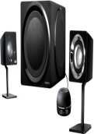 | Creative GigaWorks T3 2.1 | - 2.1 Channel Configuration  - 1 Subwoofer  - 2 Satellites  - 90 dB Signal-to-Noise Ratio  30 - 20,000 Hz (Satellite) | Rs. 18500 | 18 | Rs. 14999
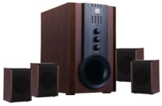 | iBall Tarang 4.1 | - 4.1 Channel Configuration  - 1 Subwoofer  - 68 dB Signal-to-Noise Ratio  - Magnetically Shielded  - 4 Satellites | Rs. 2850 | 7 | Rs. 2650
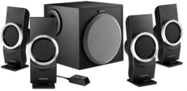 | Creative Inspire M4500 4.1 | - 4.1 Channel Configuration  - 1 Subwoofer  - 2 x 3.5 mm Audio Input  - 4 Satellites  - 80 dB Signal-to-Noise Ratio | Rs. 3899 | 0 | Rs. 3899
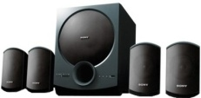 | Sony SA-D10 4.1 | - 4.1 Channel Configuration  - Total Output 70 W  - Wooden Chassis  - Digital Amplifier  - USB Playability | Rs. 6999 | 5 | Rs. 6599
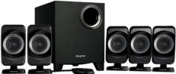 | Creative Inspire T6160 5.1 | - 5.1 Channel Configuration  - 1 Subwoofer  - 4 Satellites with 1 Center Satellite  - Magnetically Shielded  - 75 dB Signal-to-Noise Ratio | Rs. 4999 | 10 | Rs. 4495
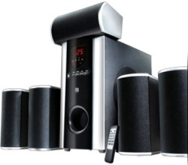 | iBall Booster 5.1 | - 5.1 Channel Configuration  - 4 Satellites with 1 Center Satellite  - Magnetically Shielded Wood Chassis  - 75 dB Signal-to-Noise RatiTotal Output of 120 W RMS | Rs. 8500 | 14 | Rs. 7290
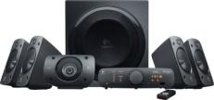 | Logitech Z906 | - 5.1 Channel Configuration  - 1 Subwoofer  - 4 Satellites with 1 Center Satellite  - Wall Mountable Satellites  - Total Output of 500 W RMS | Rs. 29995 | 13 | Rs. 25999
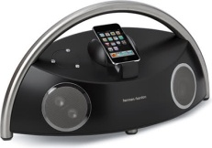 | JBL Harman Kardon Go Micro | - 2.2 Channel Configuration  - 2 Subwoofer  2 Satellites  iphone and ipod Compatible devices  Docking speakers | Rs. 19999 | 5 | Rs. 18900
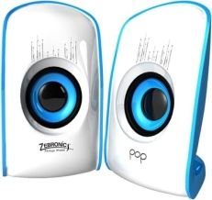 | Zebronics Pop 2.0 | - 2.0 Channel Configuration  - 2 Satellites  - Total Output of 6 W RMS  - 3.5 mm Stereo Jack  250 - 20,000 Hz (Satellite) | Rs. 650 | 46 | Rs. 349
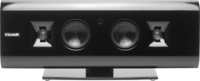 | Klipsch Gallery G-17 Wireless Airplay | - 2 Woofers  - Total Output of 60 W RMS  - Tweeter Support  - 102 dB SNR  - 1 USB Port | Rs. 29900 | 10 | Rs. 26900

